ASSOCIATION OF HOME-BASED HEALTHCARE PROFESSIONAL AND CAREGIVERS

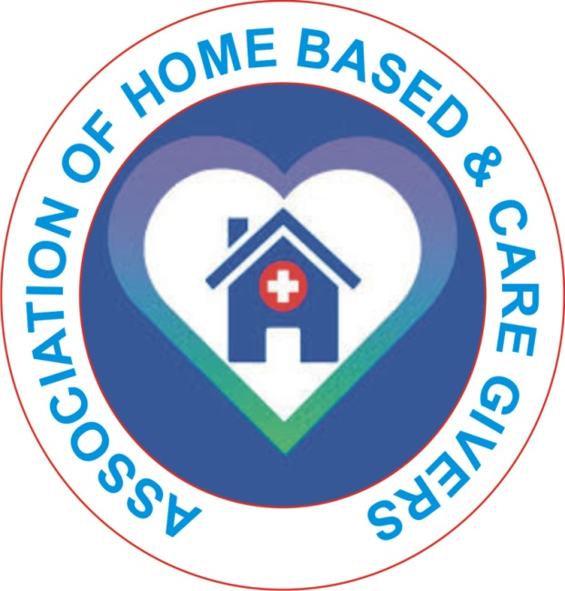

STANDARD CODE OF PROFESSIONAL
ETHICS / PRACTICE

INTRODUCTION
Definition:
The Association of Home-Based Healthcare Professionals and Caregivers provide medical, therapeutic, or supportive services to individuals in their homes. It is a established under the CAC Act of the federal Republic of Nigeria with the mandate to advance the cause of public health by providing training and education to home based healthcare professionals and caregivers
AIMS AND OBJECTIVES OF THE ASSOCIATION
To promote the well being of individual by fostering collaboration among health care providers, patient and families.
To reduce healthcare disparities by increasing access to home base health care services in underserved communities through advocacy and resourse mobilization
To contribute to healthcare policy development by advocating for policies that support home based care and improve the overall health and well being of the population

The promote the interest and welfare of our members

HEALTHCARE PROFESSIONALS AND CAREGIVERS
- Physicians
- Paramedics
- Registered Nurses RNs
- Complementary Healthcare Practitioners
- Social Worker
- Dietitian
- Physical Fitness Expert
- Psychologist
- Licensed Practical Nurses (LPNs)/Licensed Vocational Nurses (LVNs
- Physical Therapists
- Occupational Therapists
- Speech Therapists
- Home Health Aides (HHAs
- Rehabilitation Therapist
- Personal Care Aides (PCAs)
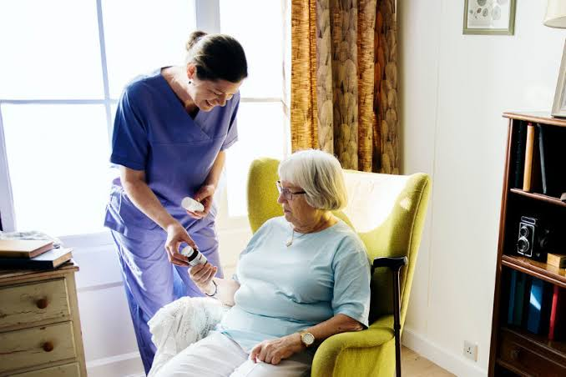
2.5 BENEFITS OF REGISTRATION
ONLY CURRENT REGISTERED MEMBERS
a. Are entitled to associate with the council on issues connected with training and practice of the professions
b. Will be allowed to participate in compulsory Continuing Professional Development (CPD) Programmes i.e conference seminars and workshop. etc organized by the association
c. Will be allowed
to participate in matters related to the promotions of the professionals under the association
d. Will have access to information on job opportunities available to members from the Board on range of professional, Educational, Legal and Ethical matters
e. Will have access to information on job opportunities available locally and internationally and printed guideline on many topics
f. Are qualified to be members of professional bodies of relevant professional and eligible to join clinical interest and employments groups
g. Will be entitled to the Boards, journals, bulletin, badge, newsletters, professional code of ethics and practice etc.
h. Have the right to practice his profession publicly or privately or otherwise in Nigeria shall have direct access to the Board’s website sequel to these aforementioned functions of the Council, it is expected of every practitioner to comply with the councils Standards on Conduct, Practice, Ethic and Valves, and no person shall practice as a Integrative medicine practitioner in Nigeria except in accordance with the following regulations.

3. CORE STANDARDS OF PROFICIENCY FOR PRACTITIONERS
3.1 Conditions for Registration
A person shall be qualified to register as a home-based care practitioner in Nigeria if the following requirement are met.
a. Must have graduated from professional training in an institution approved by the Association
b. Must have attended the pre-induction Seminar and passed the Board’s Examinations
c Must have been induction by the Association into the relevant Profession
d. Must have undergo internship of twelve calendar months in an approved clinical setting (as applicable to the profession)
e. Must have shown evidence of attendance of Continuing Professional Development (CPD) programs at least thirty (30) credit points in a year (for renewals only)
f. Must be a holder of a previous professional/provisional practicing license
g. Must pay any application fee(s) as may be prescribed from time to time by the council
h. Be a good character
i. Must satisfy the condition as may be prescribed by the Board for an annual renewal of license
j. Any applicant that complies fully with the above mentioned requirements shall be issued a Certificate of Registration and is therefore qualified to use the protected titles.
k. No practitioner who is not registered as a full member should use the prefixes doctor
l. No practitioner who is not also trained and licenses to practice orthodox medicine should engage in the practices
m. No practitioner should practice out of is competences and training. Any practitioner found guilty of this offense shall be expel from the council
n. All practitioners must abide by all existing Government Medical/Health Regulation and Non Health Regulation of the Country

3.2 Knowledge, Understanding and Skill
Practitioner must
a. Know the keg concepts of the biological, physical, social, psychological and clinical sciences which are relevant to his profession
b. Know how professional principles are expressed and translated into action through a number of different approaches to meet the needs of his clients
c. Have a basic qualification of a degree / diploma or equivalent qualification in Home-based care or in the relevant professional from an institution accredited by the Association
d. Maintain at all times the highest standard of professional knowledge and display character that reflects-credit to the profession
e. Be accountable for his work and take every reasonable opportunity to sustain and improve his knowledge and professional competence
f. Avail himself of the opportunities provided by the Continuing Education Programmes of both the council and the Professional body to improve on his professional knowledge skill and competence
g. Understand the need to establish and maintain a safe practice environment
3.3 Professional Relationship
Registrants must:
a. Obey lawful directives of his employers
b. Disobey all directive considered unlawful whether from a professional point of view or other wise
c. Give genuine advice on all professional issues from time to time’
d. Refuse to train or give instructions to anybody or group who is not a member of Association of home-based care Practitioners Except students from Association accredited institution
e. Maintain an exemplary life style i.e must not be involved in an infamous conduct and must be well dressed in and out of office
f. Must comply with the dress codes issued by the Association while on duty or classrooms, seminar room, examination rooms or generally in a hospital’s environment.
f. Not demand for gifts, favour or hospitality from a patients or relative of a patient who is to be or who has been in his care as a condition for service
g. Not take alcohol, pollutants or tobacco or be under the influence of narcotic drugs when on duty or likely to be called on duty
h. Not abuse any privilege relationship with patient or a privilege accesses to his properties
i. Have due regard for the customs, valves and religions belief of the patient
j. Comply with the laws of the country, state and local council where he works
k. Notify the council of any changes in his registration particulars within a reasonable time to enable the Board effect any necessary changes therein
Practitioner provided that such a registrant:
a. Shall be adequately involved in policy-making and management and
b. The clinic is constructed and equipped to ensure high quality patient care

4. PROFESSIONAL AUTONMY AND ACCOUNTABILITY
4.1 Expectations of a Practitioner
a. Be able to practice within the legal and ethical boundaries of his profession
b. Be able to practice in a non-discriminatory manner
c. Be able exercise a professional duty of care
d. Be able to maintain confidentiality and obtain informed consents
e. Know the professional and personal scope of his practice his/her limits and be able to make referrals (where and when necessary)
f. Recognize the need for effective self-management of workload and be able to practice accordingly
g. Understand the obligation to maintain fitness to practice
4.2 Professional Attributes
Practitioners must:
a. be able to work, where appropriate, in partnership with other professional’s support staff, patients, and other relatives and careers
b. Be able to contribute effectively to work undertaken as part of multi disciplinary team
c. Understand the need for effective communication throughout the care of the patient
d. At all times respect the rights and dignity of a patient
e. Keep himself informed or developments within his profession
f. Be able to refuse a treat a patient, if following assessment such refusal is deemed to be in the patient best interest and particularly when such treatment is contra-indicated

4.3 Professional Responsibilities
Registrants must:
a. Co-operate with one another to maintain and enhance the standard of the profession
b. Report any unethical, incompetence or illegal practice to the appropriate professional authorities i.e. the council or professional body
c. Must not support, endorse or promote the sale of goods related to the treatment of the patients while in clinical practice
d. Not advertise for the purpose of obtaining patients or promoting his own professional advantage, but notification of practice arrangement in the press is permissible
e. Members may use the media to inform the public of practice arrangements and validated qualifications from time to time
g. Contribute to the planning and development of service which enable individuals to achieve optimum health
5 THE BASIC REQUIREMENTS FOR PROFESSIONAL PRACTICE
5.1 Identification and Assessment of Health and Social Care Needs
Member must:
a. Be able to gather appropriate information
b. Be able to use appropriate assessment techniques
c. Be able to undertake or arrange clinical investigations as appropriate
d. Be able to analyze and evaluate information collected

